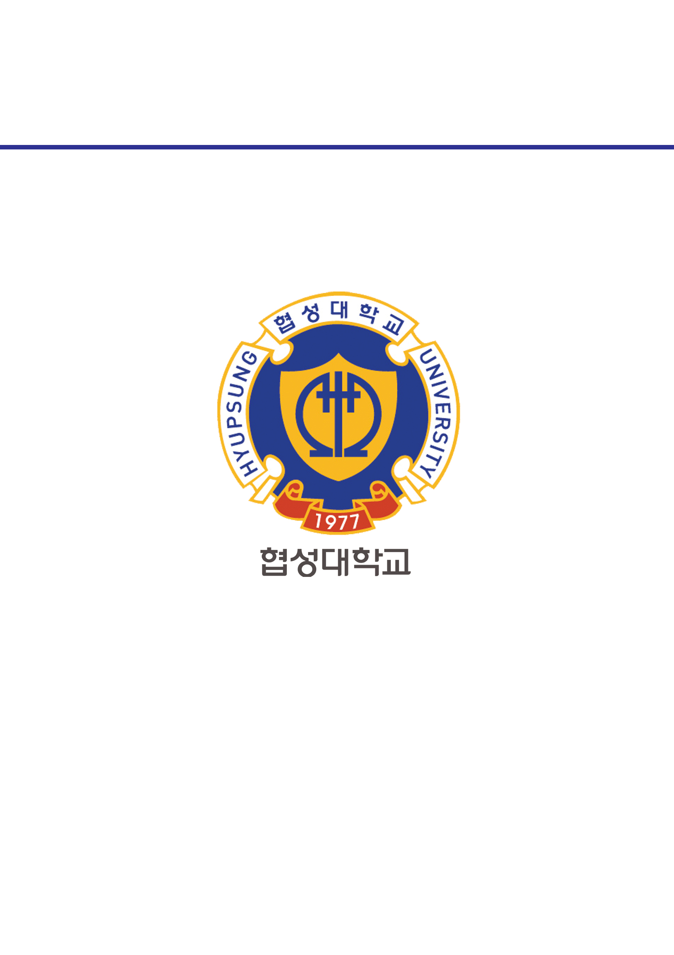­­

과목명 : IOT시스템응용

담당교수 : 봉진숙

학번 : 20170660

학과 : 컴퓨터공학과

이름 : 김동현

**REPORT**

**1. BeefPrintExample1.java**

코드)

**package** threadExam.createthread;

**import** java.awt.Toolkit;

**public** **class** BeepPrintExample1 {

**public** **static** **void** main(String[] args) {

Toolkit toolkit = Toolkit.getDefaultToolkit();

**for**(**int** i=0; i<5; i++) {

toolkit.beep();

**try** {

Thread.sleep(500);

} **catch** (InterruptedException e) {

// **TODO** Auto-generated catch block

e.printStackTrace();

}

}

**for**(**int** i=0; i<5; i++) {

System.out.println("띵");

**try** {

Thread.sleep(500);

} **catch** (InterruptedException e) {

// **TODO** Auto-generated catch block

e.printStackTrace();

}

}

}

}

실행 결과)

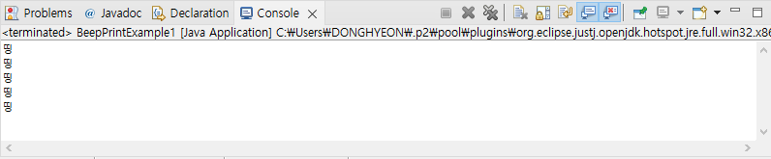

**2. BeefPrintExample2.java**

코드)

**package** threadExam.createthread;

**import** java.awt.Toolkit;

**public** **class** BeepPrintExample2 {

**public** **static** **void** main(String[] args) {

// how1

/*Runnable beepTask = new BeepTask();

Thread thread = new Thread(beepTask);*/

// how2

Thread thread = **new** Thread() {

**public** **void** run() {

Toolkit toolkit = Toolkit.getDefaultToolkit();

**for**(**int** i=0; i<5; i++) {

toolkit.beep();

**try** {

Thread.sleep(500);

} **catch** (InterruptedException e) {

// **TODO** Auto-generated catch block

e.printStackTrace();

}

}

}

};

thread.start();

**for**(**int** i=0; i<5; i++) {

System.out.println("띵");

**try** {

Thread.sleep(500);

} **catch** (InterruptedException e) {

// **TODO** Auto-generated catch block

e.printStackTrace();

}

}

}

}

실행 결과)

